

**SIMATS SCHOOL OF ENGINEERING**

**SAVEETHA INSTITUTE OF MEDICAL AND TECHNICAL SCIENCES**

**CHENNAI-602105**

**A Vehicle Rental Platform**

**A CAPSTONE PROJECT REPORT**

*Submitted in the partial fulfillment for the award of the degree of*

**BACHELOR OF ENGINEERING**

**IN**

**INFORMATION TECHNOLOGY**

**Submitted by**

**K. Dinesh (192210140)**

**T.Manohar (192210122)**

**Under the Supervision of**

**Dr. K. Jayasakthi Velmurugan**

**NOV 2024**

**DECLARATION**

We, K. Dinesh**, T. Manohar**, students of **Bachelor of Engineering in Information Technology**, Department of Computer Science and Engineering, Saveetha Institute of Medical and Technical Sciences, Saveetha University, Chennai, hereby declare that the work presented in this Capstone Project Work entitled **A Vehicle Rental Platform** is the outcome of our own bonafide work and is correct to the best of our knowledge and this work has been undertaken taking care of Engineering Ethics.

(K. Dinesh 192210140)

(T. Manohar 192210122)

Date:

Place:

**CERTIFICATE**

This is to certify that the project entitled **“A Vehicle Rental Platform”** submitted by **K. Dinesh, T. Manohar,** has been carried out under my supervision. The project has been submitted as per the requirements in the current semester of B-Tech Information Technology.

Teacher-in-charge

Dr. K. Jayasakthi Velmurugan

**Table of Contents**

|  |  |
| --- | --- |
| **S.NO** | **TOPICS** |
| 1 | **Abstract** |
| 2 | **Introduction** |
| 3 | **Project Description**  About your project |
| 4 | **Problem Description**  Program to build a simple Software for < > |
| 5 | **Tool Description**  User interface  Features |
| 6 | **Operations**  Store the First name of the student.  Store the Last name of the student.  Store the unique Roll number for every student.  Store the CGPA of every student.  Store the courses registered by the student. |
| 7 | **Approach / Module Description / Functionalities**  The idea is to form an individual functions for every operation. All the functions are unified together to form software. |
| 8 | **Implementation**  Coding |
| 9 | **Output**  Output with Screenshots |
| 10 | **Conclusion**  Future Enhancement  **References** |

**Abstract**

The rise of shared mobility has transformed urban transportation, leading to increased demand for flexible vehicle rental solutions. This paper presents a comprehensive overview of a vehicle rental platform designed to enhance user experience through a seamless digital interface and robust backend infrastructure. The platform offers a diverse fleet of vehicles, including cars, bikes, and electric scooters, catering to various consumer needs. Key features include real-time availability tracking, user-friendly booking processes, dynamic pricing models, and integrated payment systems. Utilizing advanced data analytics, the platform optimizes fleet management, ensuring efficient utilization and reduced operational costs. Additionally, the implementation of a mobile application empowers users with easy access to services, fostering greater customer engagement. The platform also addresses environmental concerns by promoting eco-friendly vehicle options and encouraging sustainable transportation practices. Overall, this vehicle rental solution aims to provide a convenient, efficient, and sustainable alternative to traditional car ownership.

**Introduction**

In today's fast-paced world, access to reliable, affordable, and flexible transportation is more important than ever. Our vehicle rental platform is designed to provide individuals and businesses with a seamless way to rent vehicles that suit their unique needs. Whether you’re looking for a car for a weekend getaway, a van for moving, or a fleet of trucks for your company’s operations, we’ve got you covered.

With a user-friendly interface, transparent pricing, and a wide selection of vehicles, we make renting easier and more convenient than ever. Our platform not only saves you time but also ensures a smooth experience through an intuitive booking process, flexible rental periods, and 24/7 customer support. By offering the right vehicle at the right time, we empower our users to move freely and efficiently, without the long-term commitment of ownership.

**Project Description**

The Vehicle Rental Platform is an online system that enables users to rent vehicles efficiently and securely. It provides a user-friendly interface for both customers seeking to rent vehicles and vehicle owners who wish to list their cars for rent. The platform is designed to simplify the vehicle rental process, offering various functionalities such as real-time vehicle availability, secure payments, and flexible rental periods. It aims to provide a seamless experience with advanced features like dynamic pricing, vehicle tracking, and customer support.

**Key Features:**

**User Registration and Profiles:**

* 1. Customers and vehicle owners can register and create profiles.
  2. Customers can view their rental history and track active rentals.
  3. Vehicle owners can list vehicles, manage bookings, and monitor earnings.

**Vehicle Listings:**

* 1. Vehicle owners can add vehicles with detailed information (model, price, availability).
  2. Customers can filter vehicles by type, location, price, and availability.

**Real-time Availability & Booking:**

* 1. Customers can view the real-time availability of vehicles.
  2. Easy booking process with calendar-based selection for pickup and return dates.
  3. Instant or scheduled booking confirmation based on availability.

**Payment Integration:**

* 1. Secure payment gateways for hassle-free transactions.
  2. Support for multiple payment methods (credit cards, wallets, etc.).
  3. Transparent billing with itemized receipts and no hidden charges.

**Program to build a simple Software for “A Vehicle Rental Platform”**

**Index.html:**

<!DOCTYPE html>

<html lang="en">

<head>

<title>RentRide - Vehicle Rentals</title>

<style>

body {

font-family: Arial, sans-serif;

background-color: #f4f4f4;

margin: 0;

padding: 0;

}

/* Center align the entire page content */

.main-container {

display: flex;

flex-direction: column;

justify-content: center;

align-items: center;

height: 100vh;

text-align: center;

}

/* Style for the title section */

.title-section {

margin-bottom: 50px;

}

h1 {

font-size: 48px;

margin: 0;

color: #333;

}

p {

font-size: 18px;

margin-top: 10px;

color: #555;

}

/* Style for the welcome section */

.welcome-container {

text-align: center;

background-color: #ffffff;

padding: 20px;

border-radius: 10px;

box-shadow: 0 4px 8px rgba(0, 0, 0, 0.1);

max-width: 400px;

width: 100%;

}

.btn {

display: inline-block;

margin: 10px 0;

padding: 10px 20px;

background-color:blue;

color: white;

text-decoration: none;

border-radius: 5px;

cursor: pointer;

transition: background-color 0.3s ease;

}

body {

background-image: url('https://static.toiimg.com/thumb/resizemode-4,width-1200,height-900,msid-80750857/80750857.jpg');

background-repeat: no-repeat;

background-attachment: fixed;

background-size: 100% 100%;

}

</style>

</head>

<body>

<div class="main-container">

<div class="title-section">

<h1>RentRide</h1>

<p>People don’t take trips,<br>trips take people</p>

</div>

<!-- Welcome container with login and signup buttons -->

<div class="welcome-container">

<h2>Welcome to RentRide</h2>

<p>Browse our fleet of vehicles and book your rental today!</p>

<a href="login.html" class="btn" target="_blank">Login</a>

<a href="signup.html" class="btn btn-signup" target="_blank">Sign Up</a>

</div>

</div>

</body>

</html>

**Tool Description**

A streamlined and user-friendly platform designed for renting vehicles, offering a seamless experience for both customers and administrators. Below are the key modules and functionalities:

### ****User Interface and Features****

### ****Admin Features****

#### ****Login****

* Admins have a secure login portal to access their dashboard and manage the platform's backend operations.

#### ****Add Vehicle****

* Admins can add new vehicles to the platform by entering vehicle details like make, model, type, and price per day/hour.

#### ****Manage Vehicle Details****

* Admins can update existing vehicle information, including vehicle type, pricing, availability, and images to keep the inventory accurate.

#### ****Manage Booking Details****

* Admins can view all bookings and approve or decline user bookings based on availability, payment, or other factors.

#### ****My Profile****

* Admins can update their profile, including contact details, password, and preferences for managing notifications and platform alerts.

### ****User Features****

#### ****Register****

* New users can sign up using an easy registration form requiring basic information like name, email, and contact number.

#### ****Login****

* Registered users can securely log in to their accounts to access booking services and other platform features.

#### ****Search Vehicle Details****

* Users can browse and search for vehicle details, comparing prices, availability, and specifications before booking.

#### ****Select Vehicle & Make Booking****

* After choosing a vehicle, users can complete a booking by providing personal details (name, customer number, address) and selecting a vehicle type.

#### ****View Booking Status****

* Users can monitor the status of their current bookings, whether it's confirmed, pending, or completed, through their profile.

#### ****My Profile****

* Users have access to a personal profile where they can update contact information, view past and upcoming rentals, and manage preferences for communication.

This platform ensures a smooth experience for customers looking to rent vehicles, while giving admins all the tools they need to manage vehicles, bookings, and user data efficiently.

**Implementation**

**Confirmation.html:**

<!DOCTYPE html>

<html lang="en">

<head>

<meta charset="UTF-8">

<meta name="viewport" content="width=device-width, initial-scale=1.0">

<title>Confirmation</title>

<style>

body {

font-family: Arial, sans-serif;

background-color: #f4f4f4;

margin: 0;

padding: 0;

text-align: center;

padding: 20px;

}

.confirmation-container {

background-color: white;

border: 1px solid #ccc;

border-radius: 5px;

padding: 20px;

display: inline-block;

margin-top: 50px;

}

.submit-button {

background-color: #4CAF50;

color: white;

padding: 10px;

border: none;

cursor: pointer;

font-size: 16px;

}

.submit-button:hover {

background-color: #45a049;

}

h2 {

color: #4CAF50;

}

p {

font-size: 18px;

color: #555;

}

</style>

</head>

<body>

<div class="confirmation-container">

<h2>Confirmation Successful!</h2>

<p>Your booking has been successfully confirmed. Thank you for choosing our service!</p>

<!-- Button to track booking details -->

<button class="submit-button" onclick="redirectToTrackBooking()">View Booking Details</button>

</div>

<script>

// Function to redirect to the booking tracking page

function redirectToTrackBooking() {

window.location.href = 'track-booking.html'; // Replace with the actual tracking page URL

}

</script>

</body>

</html>

<https://github.com/lakshmiprasanna2611/Internet-Programing>

**Output:**

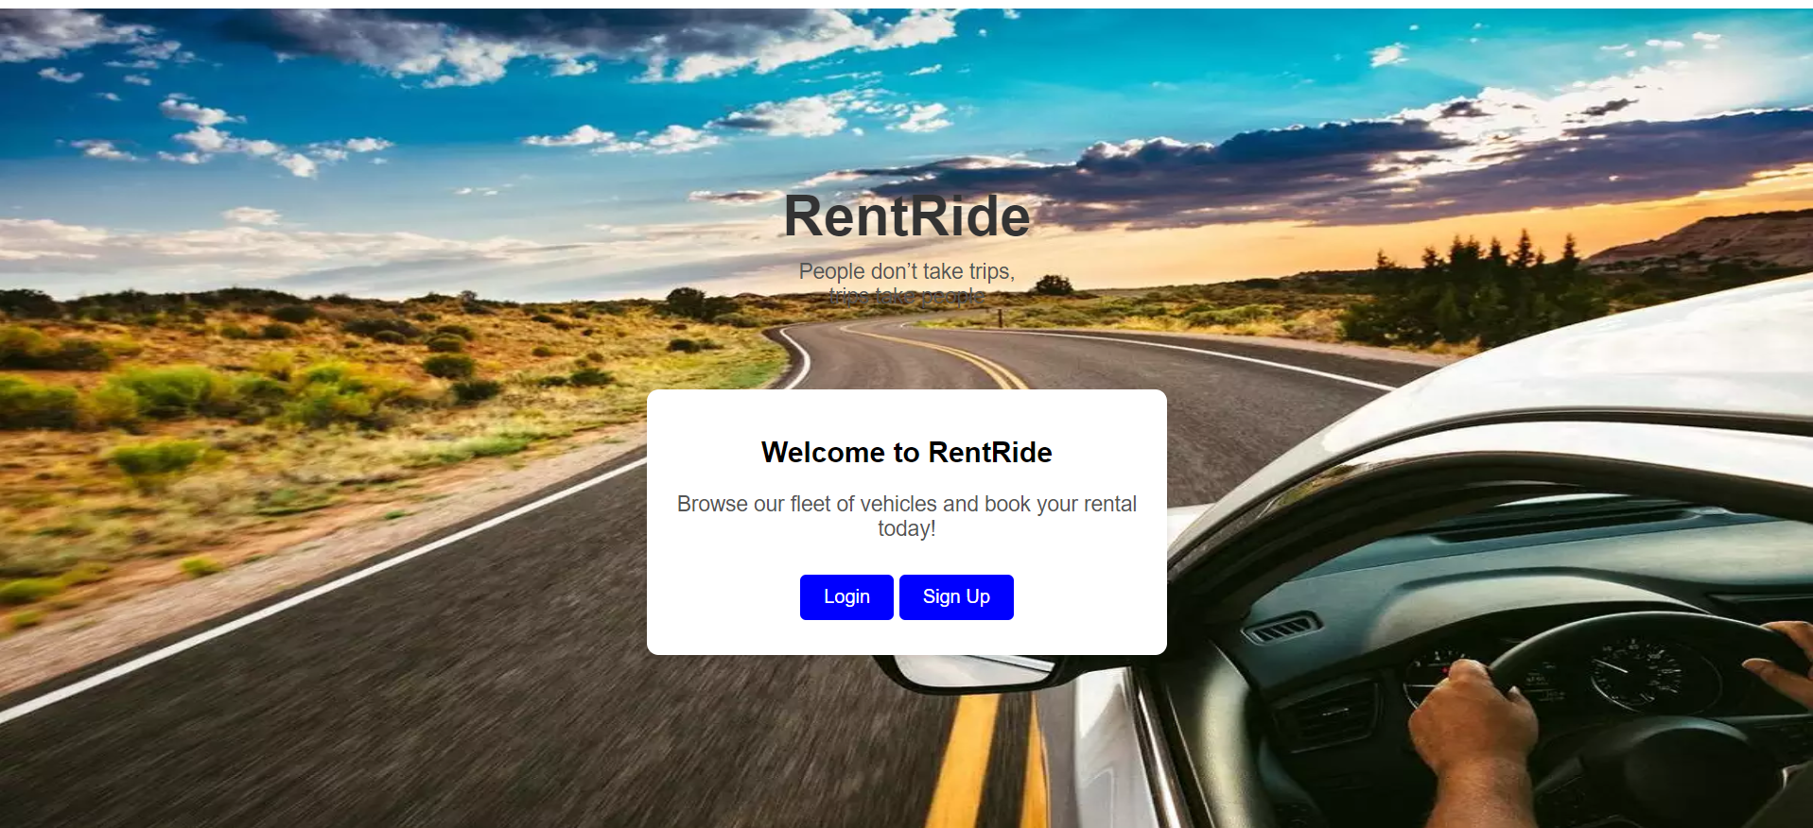

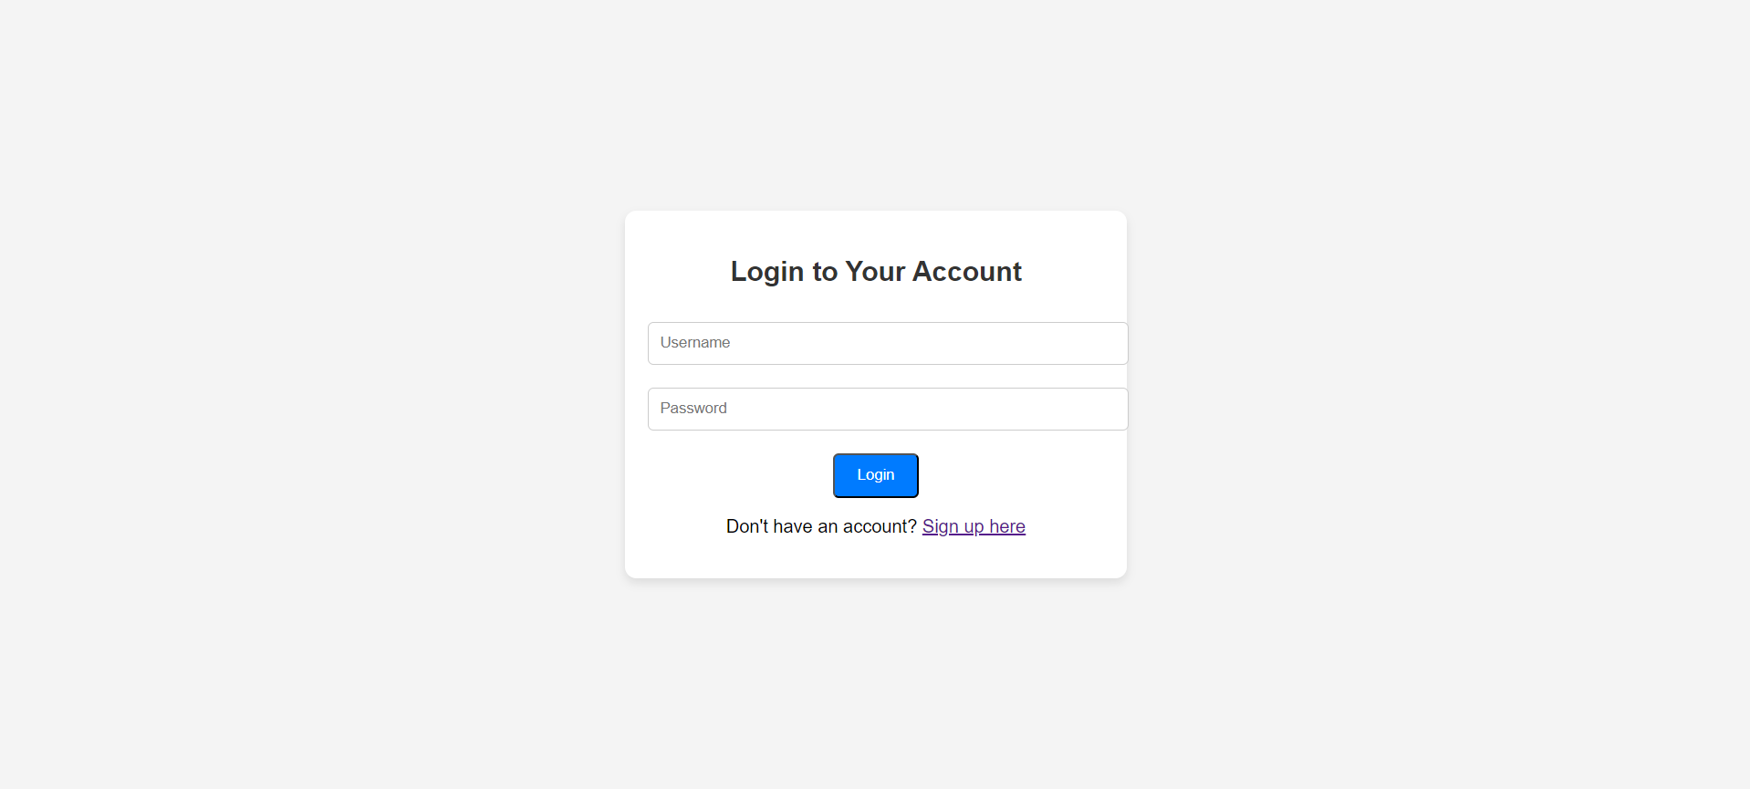

**Conclusion**

Here are some **future enhancements** that can be made to a **vehicle rental platform** improving the user experience and adding modern functionalities:

### ****1. Real-Time Vehicle Availability Status****

* **Description**: Implement real-time tracking of vehicle availability across multiple locations using JavaScript with API calls.
* **Enhancement**: As users search for vehicles, they can instantly see which vehicles are available without refreshing the page.
* **Technology**: JavaScript (AJAX for real-time updates), HTML, and CSS.

### ****2. Interactive Booking Calendar****

* **Description**: Create an interactive calendar for booking where users can see available slots for vehicle rentals.
* **Enhancement**: Users can visually select available dates for vehicle pickup and drop-off.
* **Technology**: JavaScript (date picker libraries like Flatpickr), HTML, CSS (for custom styling).

### ****3. Vehicle Comparison Tool****

* **Description**: Enable users to compare multiple vehicles side-by-side based on price, type, availability, and features.
* **Enhancement**: Users can make more informed decisions by directly comparing the pros and cons of different vehicles.
* **Technology**: JavaScript (dynamic content generation), CSS (for responsive comparison tables), HTML.\